Grenada Facts and Culture

- Family: Grenadian families tend to be quite large, and couples usually have between two and six children. Grandparents, uncles, aunts, cousins... More
- Fashion: Sloppy and casual is not the normal dress for residents of Grenada. They take great pride in their appearance. Red,... More
- Visiting: If someone says they will "pass by" that means they will come and visit you. More
Grenada Facts
Grenada stats
Capital | Saint George's
Government Type | parliamentary democracy and a Commonwealth realm
Currency | XCD
Population | 109,590
Total Area | 133 Square Miles  344 Square Kilometers
Location | Caribbean, island between the Caribbean Sea and Atlantic Ocean, north of Trinidad and Tobago
Language | English (official), French patois
Map of Grenada
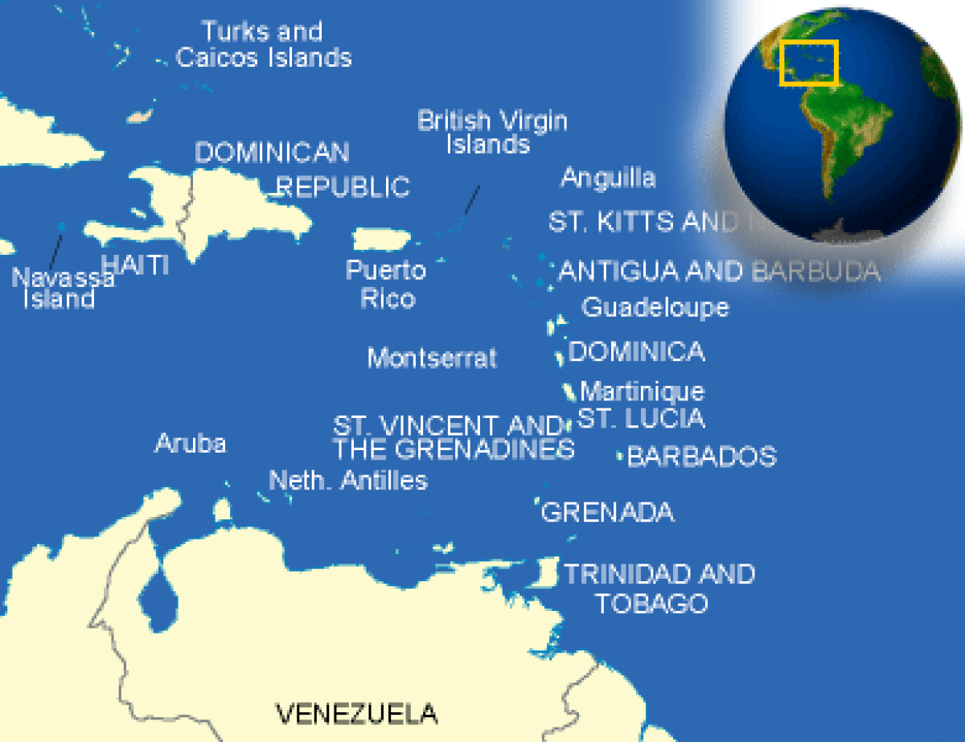

Grenada Geography
Terrain and geography
Grenada, volcanic in orgin, is referred to as the "Isle of Spice." The most southerly of the Windward Islands, it is situated between 12°N and 61°W, 90 miles north of Trinidad and southwest of Barbados. It is roughly oval shaped, 21 miles long, and about 12 miles wide. The three-island nation includes Carriacou, largest island in the Grenadine chain, and neighboring Petit (pronounced "Petty") Martinique. Grenada comprises 133 square miles of rugged, mountainous terrain, with lush tropical rain forest and little lowland. Its central mountains rise about 2,000 feet above sea level. More spices per square mile are grown here than in any other place in the world. The clear, clean air is sometimes fragrant with their aroma.
Carriacou has an area of 13 square miles and has similar geographical characteristics but lower elevations (nearly 1,000 feet). Petit Martinique, with a population of 700, has no tourist facilities but is famous for boat building.
Geography - note
the administration of the islands of the Grenadines group is divided between Saint Vincent and the Grenadines and Grenada
Grenada Geography
Geographic Location | The Caribbean
Total Area | 133 Square Miles  344 Square Kilometers
Land Area | 133 Square Miles  344 Square Kilometers
Irrigated Land | 1 Square Miles  2 Square Kilometers
Coastline | 75 Miles  121 Kilometers
Geographic Coordinates | 12 07 N, 61 40 W
Terrain | volcanic in origin with central mountains
Highest Point | 840 Meters
Highest Point Location | Mount Saint Catherine 840 m
Lowest Point Location | Caribbean Sea 0 m
Natural Resources | timber, tropical fruit, deepwater harbors

Grenada Weather and Climate
Climate and Weather
Grenadaâ€™s climate is sunny and tropical, averaging 80°F, with dry and rainy seasons. The dry season, January through May, is more comfortable; with cooling trade winds and occasional showers. The rainy season, June through December, has a more humid climate and moderate-to-heavy rainfall, which varies considerably each year. Temperatures drop in the evening, making it pleasantly cool. Sunrise is at 6:30 am and dusk varies between 6 and 6:30 pm, according to the time of year.

The wet season is characterized by heavy rains, high wind, and hurricanes, but the last hurricane to actually hit Grenada was Hurricane Janet in 1955.

Grenada Environmental Issues
Climate | Grenadaâ€™s climate is sunny and tropical, averaging 80°F, with dry and rainy seasons. The dry season, January through May, is more comfortable; with cooling trade winds and occasional showers. The rainy season, June through December, has a more humid climate and moderate-to-heavy rainfall, which varies considerably each year. Temperatures drop in the evening, making it pleasantly cool. Sunrise is at 6:30 am and dusk varies between 6 and 6:30 pm, according to the time of year.  The wet season is characterized by heavy rains, high wind, and hurricanes, but the last hurricane to actually hit Grenada was Hurricane Janet in 1955.
Terrain | volcanic in origin with central mountains
Natural Resources | timber, tropical fruit, deepwater harbors
Natural Hazards | lies on edge of hurricane belt; hurricane season lasts from June to November
Irrigated Land | 1 Square Miles  2 Square Kilometers
Environmental Issues | NA
Environment - International Agreements | party to: Biodiversity, Climate Change, Climate Change-Kyoto Protocol, Desertification, Endangered Species, Law of the Sea, Ozone Layer Protection, Whaling  signed, but not ratified: none of the selected agreements

Grenada Population Details
Population | 109,590
Population Growth Rate | 0.52%
Urban Population | 39.1%
Population in Major Urban Areas | SAINT GEORGE'S (capital) 41,000
Nationality Noun | Grenadian(s)
Nationality Adjective | Grenadian
Ethnic Groups | black 82%, mixed black and European 13%, European and East Indian 5% , and trace of Arawak/Carib Amerindian
Languages | English (official), French patois
Rate of Urbanization- annual rate of change | 1.24%

Grenada Population Details
Population | 109,590
Population Growth Rate | 0.52%
Urban Population | 39.1%
Population in Major Urban Areas | SAINT GEORGE'S (capital) 41,000
Nationality Noun | Grenadian(s)
Nationality Adjective | Grenadian
Ethnic Groups | black 82%, mixed black and European 13%, European and East Indian 5% , and trace of Arawak/Carib Amerindian
Languages | English (official), French patois
Rate of Urbanization- annual rate of change | 1.24%

Grenada Crime
Crime Information
Crime in Grenada is mostly opportunistic. Tourists have been the victims of robbery, especially in isolated areas, and thieves frequently steal credit cards, jewelry, cameras, U.S. passports, and money. Muggings, purse snatchings, and other robberies may occur in areas near hotels, beaches and restaurants, particularly after dark. Travelers should endeavor to stay in well lit areas, and avoid walking alone whenever possible, and hotel rooms should remain locked at all times. Recently, the St. George’s main market square and the Grand Anse area known as Wall Street have experienced decreases in crime since the vendors have been working as a team and now have employed security in the area.
Visitors should exercise appropriate caution when walking after dark or when using the local bus system or taxis hired on the road. It is advisable to hire taxis to and from restaurants and to ask whether the driver is a member of the Grenada Taxi Association (GTA). Members of the GTA are required to pass additional driving tests and receive training from the Grenada Tourism Board. They are generally reliable and knowledgeable about the country and its attractions.
In many countries around the world, counterfeit and pirated goods are widely available. Transactions involving such products may be illegal under local law. In addition, bringing them back to the United States may result in forfeitures and/or fines.
Grenada Penalties for Crime
Criminal Penalties
While you are traveling in Grenada, you are subject to its laws even if you are a U.S. citizen. Foreign laws and legal systems can be vastly different than our own. If you break local laws in Grenada, your U.S. passport won’t help you avoid arrest or prosecution. It’s very important to know what’s legal and what’s not where you are going.
Engaging in sexual conduct with children or using or disseminating child pornography in a foreign country is a crime, prosecutable in the United States.
Persons violating Grenada laws, even unknowingly, may be expelled, arrested, or imprisoned. Penalties for possessing, using, or trafficking in illegal drugs in Grenada are severe, and convicted offenders can expect long jail sentences and heavy fines.
Please note that a person can be prosecuted for using foul language in the presence of an officer of the law.
If you are arrested in Grenada, authorities of Grenada are required to notify the nearest U.S. Embassy or Consulate of your arrest. If you are concerned the Department of State may not be aware of your situation, you should request the police or prison officials to notify the nearest U.S. embassy or consulate of your arrest.

Grenada Life Expectancy
Life Expectancy At Birth | 73 Years
Life Expectancy At Birth- Female | 76 Years
Life Expectancy At Birth- Male | 71 Years
Median Age (female) | 29 Years
Median Age (male) | 29 Years
Median Age | 29 Years

Grenada Literacy
Predominant Language | English (official), French patois
Literacy Definition | age 15 and over can read and write
Literacy Total | 96%

Grenada Education
Education Expenditures - percent of GDP | 3.9%
Literacy - total population | 96%
Literacy Definition | age 15 and over can read and write
School Life Expectancy - female | 16 Years
School Life Expectancy - male | 15 Years
Total School Life Expectancy - (primary to tertiary) | 16 Years

Grenada Government
Capital Name | Saint George's
Country Name | Grenada
Government Type | parliamentary democracy and a Commonwealth realm
Capital - geographic coordinate | 12 03 N, 61 45 W
National Holiday | Independence Day, 7 February (1974)
Constitution | 19 December 1973
Legal System | common law based on English model
Suffrage | 18 years of age; universal

Grenada Government and Politics
Government Executive Branch | chief of state: Queen ELIZABETH II (since 6 February 1952); represented by Governor General Cecile LA GRENADE (since 7 May 2013)  head of government: Prime Minister Keith MITCHELL (since 20 February 2013)  cabinet: Cabinet appointed by the governor general on the advice of the prime minister  elections: the monarchy is hereditary; governor general appointed by the monarch; following legislative elections, the leader of the majority party or the leader of the majority coalition is usually appointed prime minister by the governor general
Legislative Branch | bicameral Parliament consists of the Senate (13 seats, 10 members appointed by the government and 3 by the leader of the opposition) and the House of Representatives (15 seats; members elected by popular vote to serve five-year terms)  elections: last held on 8 July 2008 (next to be held in 2013)  election results: House of Representatives - percent of vote by party - NA; seats by party - NDC 11, NNP 4
Judicial Branch | Eastern Caribbean Supreme Court, consisting of a court of Appeal and a High Court of Justice (two High Court judges are assigned to and reside in Grenada); Itinerant Court of Appeal three judges; member of the Caribbean Court of Justice (CCJ)
Regions or States | 6 parishes and 1 dependency*; Carriacou and Petit Martinique*, Saint Andrew, Saint David, Saint George, Saint John, Saint Mark, Saint Patrick
Political Parties and Leaders | Grenada United Labor Party or GULP [Gloria Payne BANFIELD]; National Democratic Congress or NDC [Tillman THOMAS]; New National Party or NNP [Keith MITCHELL]
International Law Organization Participation | has not submitted an ICJ jurisdiction declaration; non-party state to the ICCt
International Organization Participation | ACP, AOSIS, C, Caricom, CDB, CELAC, FAO, G-77, IBRD, ICAO, ICRM, IDA, IFAD, IFC, IFRCS, ILO, IMF, IMO, Interpol, IOC, ITU, ITUC, LAES, MIGA, NAM, OAS, OECS, OPANAL, OPCW, Petrocaribe, UN, UNCTAD, UNESCO, UNIDO, UPU, WHO, WIPO, WTO
Politicial Pressure Groups and Leaders | Committee for Human Rights in Grenada or CHRG; New Jewel Movement Support Group; The British Grenada Friendship Society; The New Jewel 19 Committee
Grenada Economy Data
GDP - Gross Domestic Product | $1,458,000,000 (USD)
GDP - official exchange rate | $811,000,000 (USD)
GDP - real growth rate | 0.8%
GDP Per Capita | $13,800.00 (USD)
GDP by Sector- agriculture | 5.6%
GDP by Sector- Industry | 15.8%
GDP by Sector- services | 78.5%
Population Below Poverty Line | 32%
Inflation Rate | 3.7%
Labor Force | 42,300
Labor Force By Occupation- agriculture | 11%
Labor Force By Occupation- industry | 20%
Labor Force By Occupation- services | 69%
Unemployment Rate | 12.5%
Fiscal Year | calendar year
Annual Budget | $175,300,000 (USD)
Budget Surplus or Deficit - percent of GDP | -4.1%
Taxes and other revenues - percent of GDP | 20.1%
Major Industries | food and beverages, textiles, light assembly operations, tourism, construction
Agriculture Products | bananas, cocoa, nutmeg, mace, citrus, avocados, root crops, sugarcane, corn, vegetables
Currency Code | East Caribbean dollar (XCD)
Commercial Bank Prime Lending Rate | 9.4%
Grenada Economy
Economic Overview
Grenada relies on tourism as its main source of foreign exchange, especially since the construction of an international airport in 1985. Strong performances in construction and manufacturing, together with the development of an offshore financial industry, have also contributed to growth in national output.

Grenada Exports
Exports | $38,000,000 (USD)
Major Exports | bananas, cocoa, nutmeg, fruit and vegetables, clothing, mace
Top Export Partners | US 15.2%, Germany 13%, Bangladesh 10.9%, Netherlands 8.7%, Saint Lucia 6.5%, Antigua and Barbuda 4.3%, Dominica 4.3%, France 4.3%, Saint Kitts and Nevis 4.3%, Trinidad and Tobago 4.3%, UK 4.3%

Grenada Flag
the yellow represents the sun and the friendliness of the people, the green stands for the agriculture and the red is a symbol of harmony, unity and courage. The seven stars represent the island's seven perishes. The nutmeg recalls that this small island is the second-largest producer of nutmeg in the world.
Grenada Flag Description
a rectangle divided diagonally into yellow triangles (top and bottom) and green triangles (hoist side and outer side), with a red border around the flag; there are seven yellow, five-pointed stars with three centered in the top red border, three centered in the bottom red border, and one on a red disk superimposed at the center of the flag; there is also a symbolic nutmeg pod on the hoist-side triangle (Grenada is the world's second-largest producer of nutmeg, after Indonesia); the seven stars represent the seven administrative divisions
TRANSLATE
Grenada flag
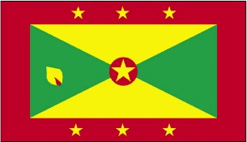

Grenada National Anthem Lyrics
Anthem Lyrics English | Hail! Grenada, land of ours,  We pledge ourselves to thee,  Heads, hearts and hands in unity  To reach our destiny.  Ever conscious of God,  Being proud of our heritage,  May we with faith and courage  Aspire, build, advance  As one people, one family.  God bless our nation.

Grenada Interesting Facts
- Before the 1850s most people on the island were employed as slaves on large estates. Many estates had hundreds of workers. Some of these estates have become tourist sites.
- By the time of the emancipation of slaves in 1834, the slave population was more than 24,000.
- Canada and Grenada both became British colonies in the same year, 1763.
- Governor Du Parquet of Martinique “purchased” Grenada from the Caribs in 1650. The payment was a few hatchets, some glass beads and a couple of bottles of alcohol.
- On Independence Day, there is a 24-kilometer relay race from St. Mark's to St. George's.
- Grenada is called the “Isle of Spice.” Nutmeg, cloves and cinnamon grow there.
- Julius Isaac, chief justice of the Federal Court of Canada, is of Grenadian heritage. Eddie Bullen is a Grenadian- born musician, arranger and composer who now lives in Canada.
- Marryshow College was named after Theophilus Albert Marryshow (1877-1958), a writer and statesman who is remembered as the “Father of the Caribbean Federation.”
- One of the world's most famous calypso artists, Slinger Francisco, known as The Mighty Sparrow, was born in Grenada. The Mighty Sparrow has performed in Toronto many times during Caribana.
- Patois is as common as English in Petit Martinique.
- People living in Carriacou and Petit Martinique have a distinct ethnic identity, which includes a strong French and Scottish heritage.
- Some Grenadians believe that the interpretation of dreams can provide a way to understand the world and people's actions. It is a way of expressing their spirituality.
- The Big Drum festival on Carriacou is celebrated with stick fighting, special foods and offerings made to the dead.
- The infant mortality rate is low and the average life expectancy for women is 74 years and for men, 69 years.
- The leatherback turtles come to Grenadian shores to lay their eggs in April, May and June. Turtle soup and turtle eggs are considered delicacies.
- The literacy rate in Grenada is high (97%). Literacy rate is measured by the number of people who are older than 15 years and who can read and write.
- The town of Sauteurs (“leapers” in French) is so named because it is believed that the last Carib warriors jumped to their death from a nearby cliff, rather than submit to the Europeans.
- There are no tall apartment blocks on the island because Grenada has a law that development may not rise above the height of a coconut palm.

History of Grenada
Before the arrival of Europeans, Carib Indians who had driven the more peaceful Arawaks from the island inhabited Grenada. Columbus landed on Grenada in 1498 during his third voyage to the new world. He named the island "Concepcion." The origin of the name "Grenada" is obscure, but it is likely that Spanish sailors renamed the island for the city of Granada. By the beginning of the 18th century, the name "Grenada," or "la Grenade" in French, was in common use.
Partly because of the Caribs, Grenada remained un-colonized for more than 100 years after its discovery; early English efforts to settle the island were unsuccessful. In 1650, a French company founded by Cardinal Richelieu purchased Grenada from the English and established a small settlement. After several skirmishes with the Caribs, the French brought in reinforcements from Martinique and defeated the Caribs, the last of whom leaped into the sea rather than surrender.
The island remained under French control until its capture by the British in 1762, during the Seven Years’ War. The Treaty of Paris formally ceded Grenada to Great Britain in 1763. Although the French regained control in 1779, the Treaty of Versailles restored the island to Britain in 1783. Although Britain was hard-pressed to overcome a pro-French revolt in 1795, Grenada remained British for the remainder of the colonial period.
During the 18th century, Grenada’s economy underwent an important transition. Like much of the rest of the West Indies it was originally settled to cultivate sugar, which was grown on estates using slave labor. But natural disasters paved the way for the introduction of other crops. In 1782, Sir Joseph Banks, the botanical adviser to King George III, introduced nutmeg to Grenada. The island’s soil was ideal for growing the spice, and because Grenada was a closer source of spices for Europe than the Dutch East Indies the island assumed a new importance to European traders.
The collapse of the sugar estates and the introduction of nutmeg and cocoa encouraged the development of smaller landholdings, and the island developed a land-owning yeoman farmer class. Slavery was outlawed in 1834. In 1833, Grenada became part of the British Windward Islands Administration. The governor of the Windward Islands administered the island for the rest of the colonial period. In 1958, the Windward Islands Administration was dissolved, and Grenada joined the Federation of the West Indies. After that federation collapsed in 1962, the British Government tried to form a small federation out of its remaining dependencies in the Eastern Caribbean.
Following the failure of this second effort, the British and the islands developed the concept of associated statehood. Under the Associated Statehood Act of 1967, Grenada was granted full autonomy over its internal affairs in March 1967. Full independence was granted on February 7, 1974.
After obtaining independence, Grenada adopted a modified Westminster parliamentary system based on the British model, with a governor general appointed by and representing the British monarch (head of state) and a prime minister who is both leader of the majority party and the head of government. Sir Eric Gairy was Grenada’s first Prime Minister.
On March 13, 1979, the New Joint Endeavor for Welfare, Education, and Liberation Movement (New Jewel Movement--NJM), ousted Gairy in a nearly bloodless coup and established a People’s Revolutionary Government (PRG) headed by Maurice Bishop, who became Prime Minister. His Marxist-Leninist government established close ties with Cuba, the Soviet Union, and other communist bloc countries.
In October 1983, a power struggle within the government resulted in the arrest and subsequent murder of Bishop and several members of his Cabinet by elements of the People’s Revolutionary Army (PRA).
Following a breakdown in civil order, a U.S.-Caribbean force landed on Grenada on October 25, 1983 in response to an appeal from the Governor General and to a request for assistance from the Organization of Eastern Caribbean States. U.S. citizens were evacuated, and order was restored.
An advisory council named by the Governor General administered the country until general elections were held in December 1984. The New National Party (NNP) led by Herbert Blaize won 14 out of 15 seats in free and fair elections and formed a democratic government. Grenada’s constitution had been suspended in 1979 by the PRG, but it was restored after the 1984 elections.
The NNP continued in power until 1989 but with a reduced majority. Five NNP parliamentary members, including two Cabinet ministers, left the party in 1986-87 and formed the National Democratic Congress (NDC), which became the official opposition.
In August 1989, Prime Minister Blaize broke with the NNP to form another new party, The National Party (TNP), from the ranks of the NNP. This split in the NNP resulted in the formation of a minority government until constitutionally scheduled elections in March 1990. Prime Minister Blaize died in December 1989 and was succeeded as Prime Minister by Ben Jones until after the elections.
The NDC emerged from the 1990 elections as the strongest party, winning seven of the 15 available seats. Nicholas Brathwaite added two TNP members and one member of the Grenada United Labor Party (GULP) to create a 10-seat majority coalition. The Governor General appointed him to be Prime Minister.
In parliamentary elections on June 20, 1995, the NNP won eight seats and formed a government headed by Keith Mitchell. The NNP maintained and affirmed its hold on power when it took all 15 parliamentary seats in the January 1999 elections.
General elections were held in November 2003; the NNP won 8 of the 15 seats, holding on to power with a much-reduced majority. The National Democratic Congress (NDC) led by Tillman Thomas won 7 seats and is now the official opposition.

Grenada History Timeline
Grenada Year in History | Grenada Timeline
1498 | Christopher Columbus sights the islands, which he names Grenada after the Spanish city.  Christopher Columbus sights the islands, which he names Grenada after the Spanish city.
1650 | French settlers from Martinique establish a colony and found Saint George’s, the present capit  French settlers from Martinique establish a colony and found Saint George’s, the present capital.
1783 | France cedes Grenada to Britain in accordance with the Treaty of Versailles.  France cedes Grenada to Britain in accordance with the Treaty of  Versailles; African slaves brought in to work on the cotton, sugar and  tobacco plantations.
1834 | Slavery abolished.  Slavery abolished.
1974 | Grenada becomes independent with Gairy as prime minister.  Grenada becomes independent with Gairy as prime minister.
2002 | Major organic banana project launched in an effort to boost the industry.  Major organic banana project launched in an effort to boost the industry; 150 acres are set aside for organic cultivation.
2004 | Grenada takes a direct hit from Hurricane Ivan.  Grenada takes a direct hit from Hurricane Ivan. Prime Minister Mitchell declares a national  disaster; he says the island is 90% devastated.

Grenada Holidays and Events
Display Date | Title
February 7th | Independence Day
December 25th | Christmas  Christmas customs include caroling groups traveling from house to house during the weeks prior to Christmas, decorations of nativity scenes, poinsettias, streamers and stars, and community Christmas trees. The Christmas dinner consists of turkey, pork, pigeon peas, yams, ginger bear and sorrel (a drink made from the red or white fleshy portion of sorrel – a plant originating in the Sudan – sweetened with sugar or fermented). The season ends on Epiphany, January 6th when all decorations are removed.

Grenada Meals and Food
Recipes from Grenada
- Callaloo Soup - Main Dish
- Callaloo Soup - Main Dish
- Callaloo Soup - Main Dish
- Chicken Pelau - Main Dish
- Curried Chick-peas - Side Dish
- Grenadian Spice Cake - Dessert
- Grenadian-Style Grilled Chicken - Main Dish
Grenada Recipes and Diet
Grenada food and meal customs
Diet
Grenadian foods have been heavily influenced by East Indian, African and French cooking. The soil is very fertile in Grenada and the ocean is another source of food.
Breadfruit, yams, sweet potatoes and cassava (manioc) are very popular foods. “Callaloo” is a dish made with meat and dasheen leaves (also known as taro leaves). Seafood such as conches (lambi), crabs and shrimps are also popular. Some dishes even use armadillo or iguana meat. Chili peppers are an integral part of many dishes.
Breadfruit can be used in many ways. It may be combined with green bananas to make a dish similar to potato salad. The breadfruit flower is eaten with sugar, and the fruit can be made into flour. A favorite Grenadian dish is “oil down,” made with breadfruit cooked in coconut milk and spiced with Grenadian saffron (turmeric).
Nutmeg and fresh mace are the most popular spices. Nutmeg is the seed of the fruit of the nutmeg tree. Mace is a red membrane that covers the nutmeg kernel inside the fruit. When the mace is dried, it fades to a yellowish-orange. It is used for seasoning wine, sauces, soups, stews and seafood. Cookies and cakes are also flavored with this pungent spice. Nutmeg is used to flavor drinks like eggnog, milk drinks, rum punches and wines.

Grenada Languages
Languages
English (official), French patois

Greetings in French patois
Merry Christmas | Joyeux Noël

Grenada Clothing and Fashion
Sloppy and casual is not the normal dress for residents of Grenada. They take great pride in their appearance. Red, Yellow and green colors are use everywhere in clothes.

Dating, Family and Children Grenada
Family and Children
Grenadian families tend to be quite large, and couples usually have between two and six children. Grandparents, uncles, aunts, cousins and other extended family often live in the same house or close to one another. People living in urban areas tend to have smaller families than those living in rural areas.
The extended family usually plays a role in bringing up the children as well. Divorces are rare, although they have increased in the last two decades.
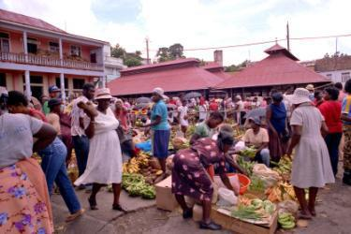
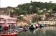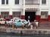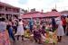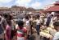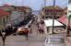

Grenada Gestures and Greetings
Greetings
Grenada has many customs for a British colony such as driving on the left side of the road. Grenadian culture is big on courtesy and not greeting people is viewed as disrespectful.
Visiting
If someone says they will "pass by" that means they will come and visit you.
Cultural Attributes
Sharing food and drink are an important part of family life, and Grenadians try to have at least one meal every day at which all the family members are present. Grenadians are very sociable people. Politics is a favorite topic of discussion. Grenadians always offer guests a refreshment and it is considered impolite to refuse.

Grenada Church and Religion
Other denominations included Presbyterian, Church of God, Baptist, Pentecostal, the Church of Jesus Christ of Latter-day Saints (Mormons), and Mennonite. There were small groups of Rastafarians, Muslims, including foreign medical students at St. George's University, and Baha'is.
Some Grenadians follow a tradition known as Shango, which has its origins in the religion of the Yoruba people of West Africa. Followers of Shango honor Olodumare as the creator god, but rather than worshiping him directly, they worship individual spirits such as Osun (god of the river) or Shango (god of thunder).
Followers of Shango dress in blue to pay homage to the sea and throw food into lakes, rivers and the sea as an offering to the spirits. According to Shango mythology, men were placed on the earth first and women were sent afterwords to deal with the defects created by, and in, men.
Reportedly more than 60 percent of the population regularly participate in formal religious services.
The constitution provides for freedom of religion, and the Government generally respected this right in practice. The Government at all levels sought to protect this right in full and did not tolerate its abuse, either by governmental or private actors.
The Government is secular and does not interfere with an individual's right to worship.
The Christian holy days of Good Friday, Corpus Christi, Easter, Whit Monday, and Christmas are national holidays.
Religious groups must register with the Prime Minister's Office, which is responsible for issuing licenses for religious groups, buildings, and events. Registration entitles them to some customs and import tax exemptions

Grenada Sport and Recreation
Cricket, soccer (called football) and netball are the most popular sports. Children play a game called rounders, which is similar to baseball. The ball is usually a tennis ball and it is hit with a cricket bat instead of a baseball bat, but as in baseball there are four bases and runs are scored in the same way.
Intercol is a popular annual sporting affair at which secondary schools compete against each other in running, jumping and other athletic events.

